TOWN OF WALES AGENDA
Select Board 3 Hollow Road
( Select Board's Office, 1s t Floor

TOWN OF WALES
Tuesday, November 13, 2018
5 pm

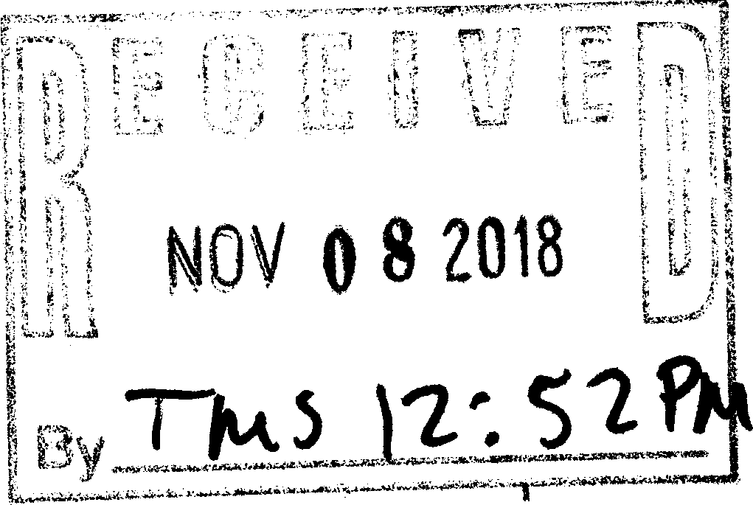
Old Business:

Tax Title Auction HVAC Prevailing Wage USA Hauling
Library Ramp Invoice Appointments: New Business:

Resume/Letter of Interest Interim Senior Van Driver

Letters of Interest Wales Cultural Council

Inspector Accounts
Fee and Form for Building Inspection Sump Pump for Town Hall
Grant Writer Job Description
( Classification Hearing
Board Executive Secretary Pay

Mail:

Charter Communication Changes

Announcements:

*Note: The items listed which may be discussed at the meeting are those reasonably anticipated by the Chair. Not all items listed may in fact be discussed and other items not listed may also be brought up for discussion to the extent permitted by law. Members of the Board, Executive Secretary, Staff, or Others, who prepare background material for the meeting, should make an effort to have such material available by Tuesday morning. If background information is insufficient or complicated, or if complex memos or motions are presented at the meeting, which were not in the Board's meeting packet, any member should feel free to request the tabling of the item to allow careful study of the material presented or the motion. All available documents regarding the Meeting's Agenda Items, shall be made available the following business day, after the meeting, per request.

(

