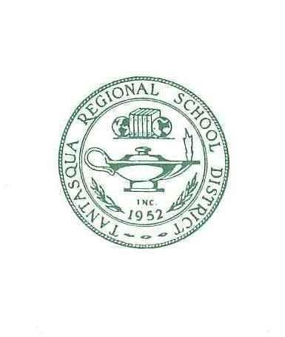
Tantasqua Regional/School Union 61 Districts
320A Brookfield Rd., Fiskdale, MA 01518
(508)347-3077
FAX (508)347-2697

Deborah J Boyd
Superintendent of Schools

Jodi Bourassa Kristen Leo
Assistant Superintendent Business and Finance Director

Jessica Bolduc Gregory Rossow
Special Education Director Technology Director

WALES SCHOOL COMMITTEE
Meeting of Wednesday, January 3, 2023
6:00 p.m.
Wales Elementary School
AGENDA
- Pledge of Allegiance
- Approval of Minutes
- November 1, 2023 Regular Session
- Financial Report
- Communications
- Budget Liaisons Memo
- Principal’s Report
- Superintendent’s Report
- FY25 Budget
- Tantasqua Representative Report
- Public Access
- Unfinished Business
- EB Safety Program - Amend First Reading
- EC Buildings and Grounds Management - Amend First Reading
- ECA Buildings and Grounds Security - Amend First Reading
- ECAF Security Cameras in School - Amend First Reading
- JLC-1 Wellness Policy - Amend First Reading
- JLCD Administering Medicines to Students - Amend First Reading

- New Business
- GBEA Staff Ethics / Conflict of Interest - NEW First Reading
- GBEB Staff Conduct - NEW First Reading
- GBEBC Gifts To and Solicitations By Staff - NEW First Reading
- GBEBD Online Fundraising and Solicitations - Crowdfunding - NEW First Reading
- GBGB Staff Personal Security and Safety - NEW First Reading
- GBI Staff Participation in Political Activities - NEW First Reading
- GBJ Personnel Records - NEW First Reading
- GCA Professional Staff Positions - NEW First Reading
- GBEC Drug-Free Workplace Policy - Amend First Reading

- Open Forum - This is an opportunity to offer comments or observations about the School Committee and its work. Motions may be made during this session to establish New Business for a subsequent meeting or to refer a topic to a subcommittee. Members are limited to two minutes each and the session shall be limited to 15 minutes.

- Adjourn
- POSTED: 12/22/2023

The items listed which may be discussed at the meeting are those reasonably anticipated by the Chair. Not all items listed may in fact be discussed and other items not listed may also be brought up for discussion to the extent permitted by law.

