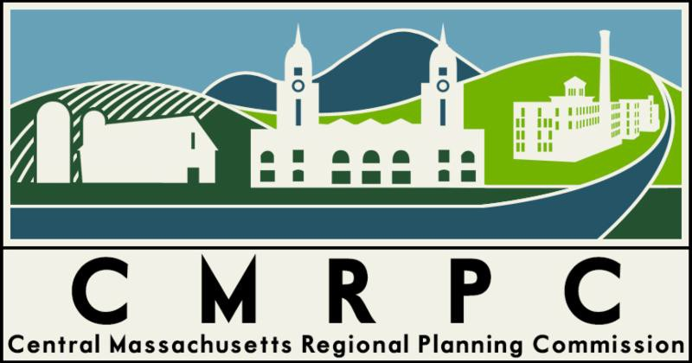

Meeting Minutes

Charlton Coalition for Public Health
November 9, 2023, 9:00am

CCPH members: Cheryl Rawinski (Sutton), Lisa Daoust (Spencer), Ken Lacey (Sturbridge)

Staff/guests: Ethan Melad (CMRPC),Andrea Jachimczyk (Charlton), Mary Carpenter (Charlton), Michelle Blanchard (Wales)

- Open @ 9:03am
- Approval of 10/12/23 minutes
  - Motion by Cheryl, seconded by Ken. Approved unanimously.
- Discussion:
  - Possibility of part time outreach/health educator position to provide relief for Mary
    - Look at programs for smoking cessation, car seats from Umass
    - Be aware of existing programs/staffing so as to avoid duplication
  - Cheryl mentioned NARCAN trainings & will look at program & assoc. costs
    - Derek Fullerton (sp?) @ MHOA discussed free supplies/training
- Meeting adjourned 9:42am

Submitted by Ethan Melad, CMRPC

